5.3: a) The two sides of the rope each exert a force with vertical component T 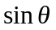, and the sum of these components is the hero’s weight. Solving for the tension T,
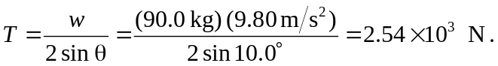
b) When the tension is at its maximum value, solving the above equation for the angle gives
